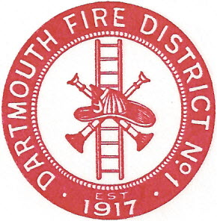
Dartmouth Fire District No.1
10 Bridge Street • Dartmouth, MA 02748
Telephone (508) 996-1596 • Fax (508) 984-4521

Agenda for October 12, 2017 @ 6:30 PM

- Vendor Warrant
- Payroll Warrant
- Building Maintenance
- Equipment Maintenance
- Chiefs Vacation / comp hours
- 2017 Audit
- Open session {old fire station}
- Adjourn

